**04/10/2021 ML SPOT 5 2019103573**

**SINGLE LAYER PERCEPTRON**

**AND PROBLEM**

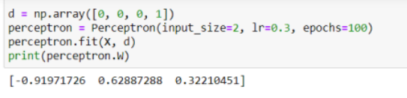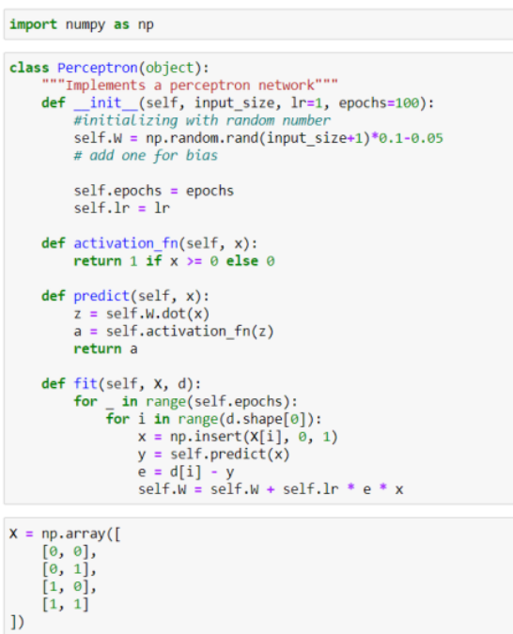**CODE :-**

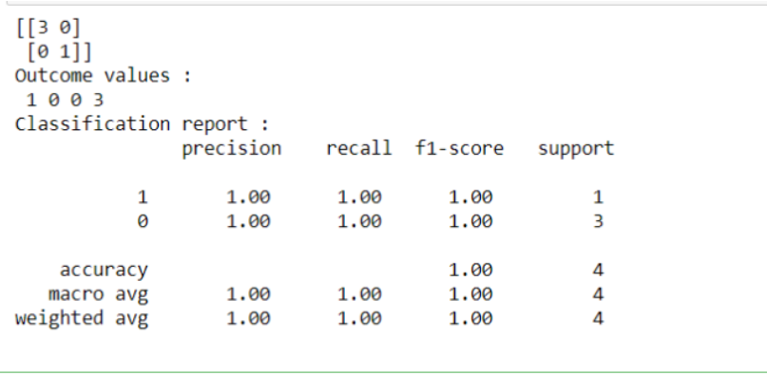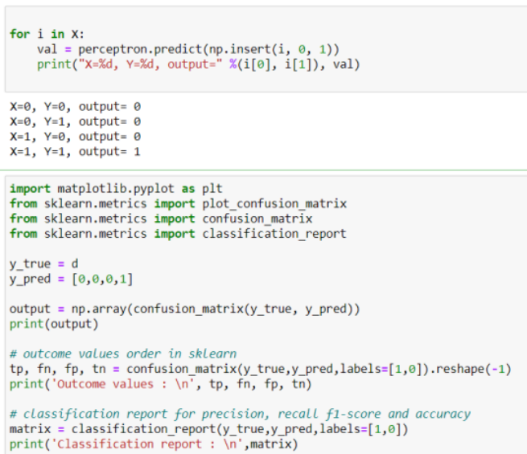

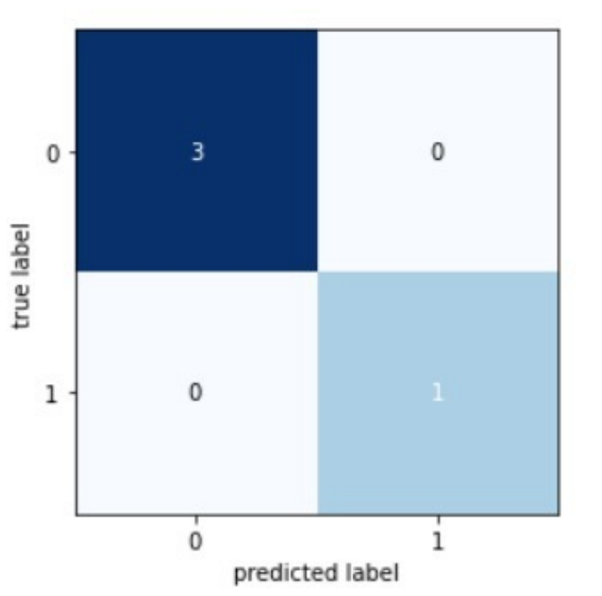**CONFUSION MATRIX:-**

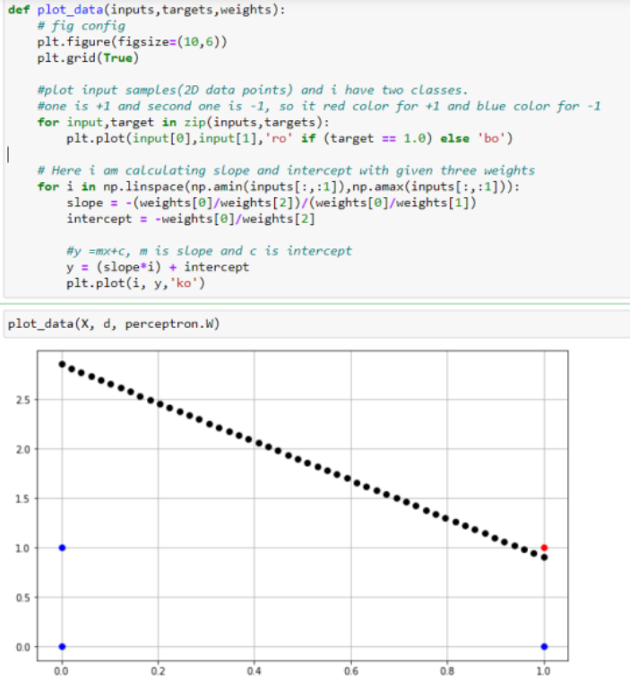**DECISION BOUNDARY:-**

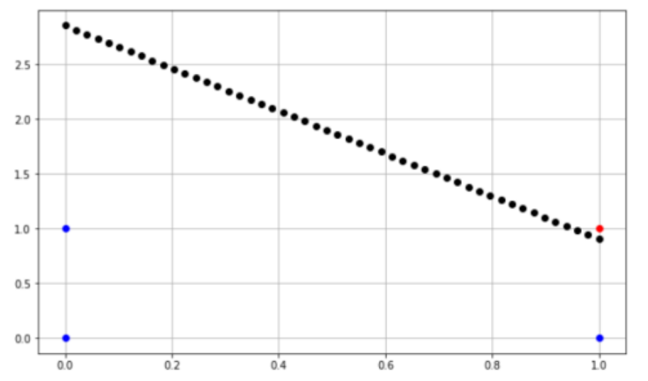

**The performance measure is accuracy and this performs 100%.**

**OR PROBLEM**

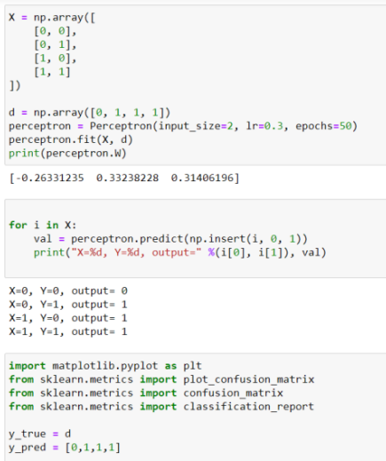**CODE :-**

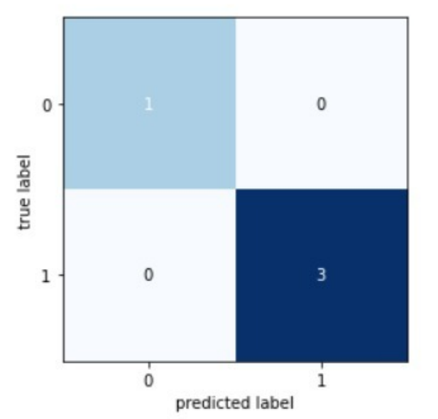

**Performance measure is accuracy, and this performs 100%**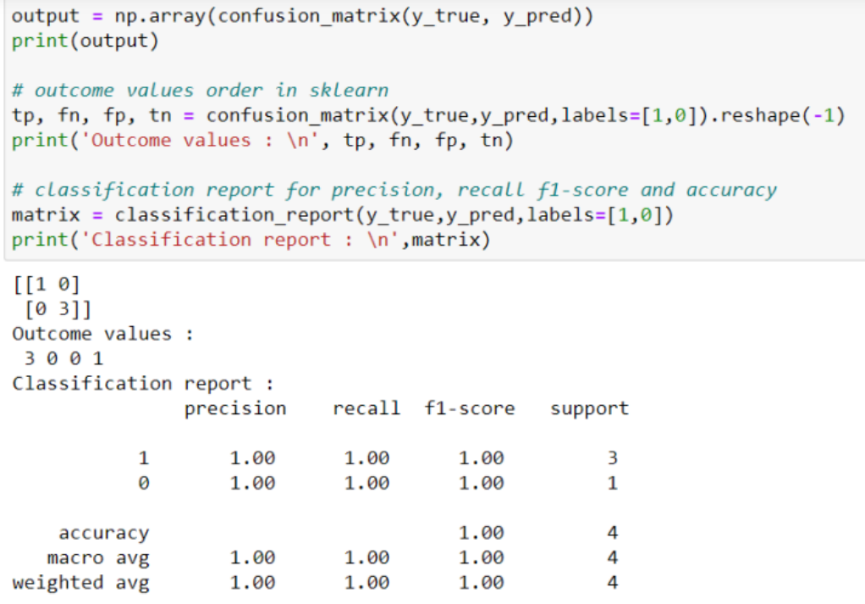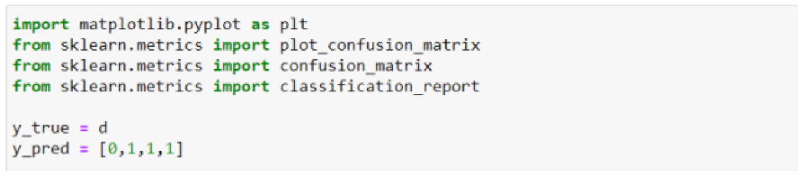

**XOR PROBLEM**

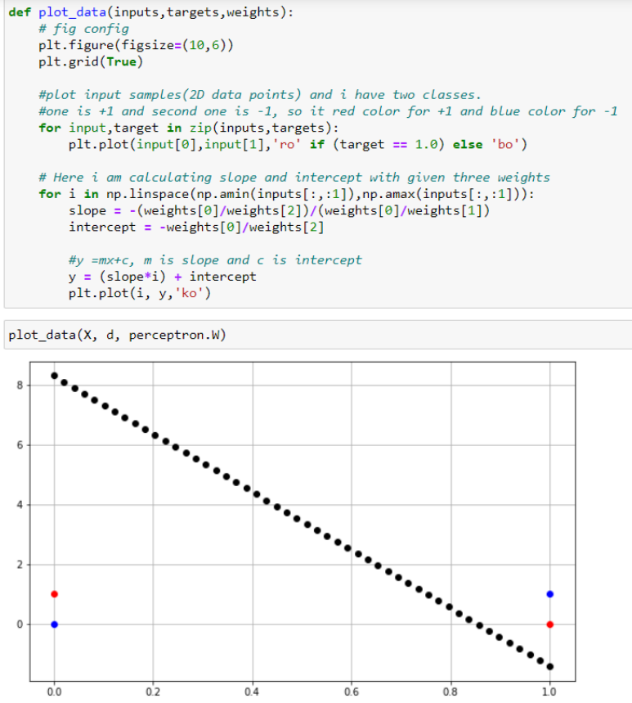**DECISION BOUNDARY:-**

**Performance Measures:- accuracy (50%)**

Since perceptrons are limited to solving problems that are linearly separable. Two classes are linearly separable means that we can draw a single line to separate the two classes. We can do this easily for the AND and OR gates, but there is no single line that can separate the classes for the XOR gate. This means that we can’t use our single-layer perceptron to model an XOR gate.